**Module 2: Sequence Manipulation**

**1. List Sequences**

**1.1 Intro Python**

Jupyter Notebook: Mod2_2-2.1_Intro_Python.ipynb

## **Sequence: Lists**

* **List Creation**
* **List Access**
* List Append
* List Insert
* List Delete

# Student will be able to

* **Create Lists**
* **Access items in a list**

**1.2 Creating List**

**Video:** **CreatingListV1.mp4**

**We can easily create lists in Python. In our first code cell, we have a variable that we want to initialize as a list of strings. It's called ft_bones, we are going to initialize it by using these square brackets which identify that we're creating a list. List items will be separated with commas.** Here we have a list of strings again. We're gonna print out that list. **See what the type of the list is, ft_bones, the list is a list.** And printed out we cansee the list items.

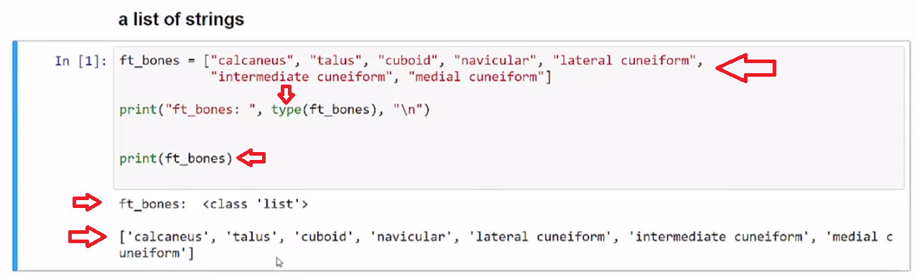

**We can also create a list made of integers.** Here age_survey, again, has the brackets at each end, containing the list. And separates each object with commas. **The type of a list of integers is also list**, and we see the list printed out.

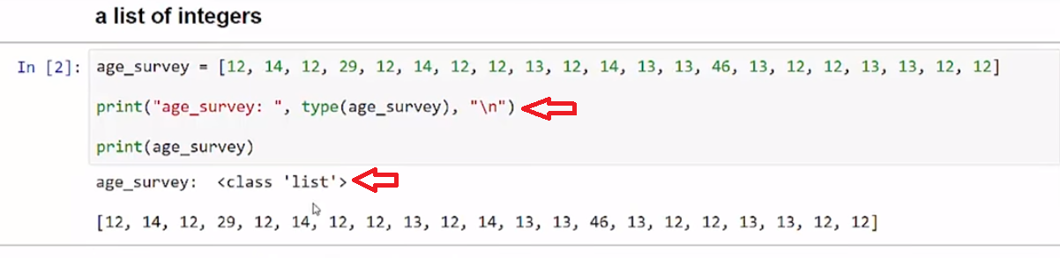

**We can also mix our lists. Here the brackets that define the list contain integers, strings, and even other lists. A mixed_list is of type list.** And then you can see, we print out our integers, our strings, and the list itself that is contained of ft_bones andof the age_survey.

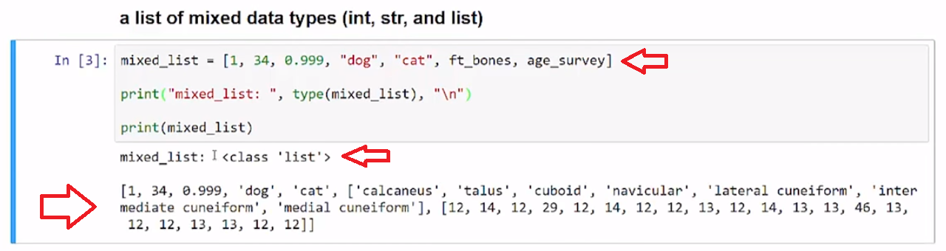

We can create a simple list with brackets that contain objects separated by commas.

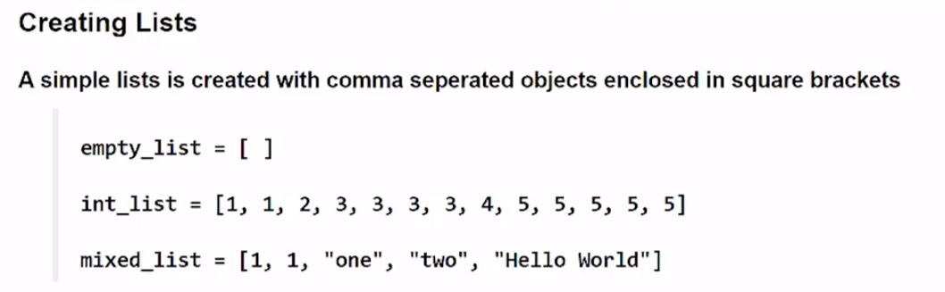

# Concept

## **Creating Lists**

A simple lists contains **comma separated** objects enclosed in **square brackets**

empty_list = [ ]

sample_list = [1, 1, 2, 3, 3, 3, 3, 4, 5, 5, 5, 5, 5]

List object types are not restricted so a mix of object types can be in single list

mixed_list = [1, 1, "one", "two", 2.0, sample_list, "Hello World"]

## **Examples**

# [ ] review and run example

# define list of strings

ft_bones = ["calcaneus", "talus", "cuboid", "navicular", "lateral cuneiform", "intermediate cuneiform", "medial cuneiform"]

# display type information

print("ft_bones: ", type(ft_bones))

# print the list

print(ft_bones)

# [ ] review and run example

# define list of integers

age_survey = [12, 14, 12, 29, 12, 14, 12, 12, 13, 12, 14, 13, 13, 46, 13, 12, 12, 13, 13, 12, 12]

# display type information

print("age_survey: ", type(age_survey))

# print the list

print(age_survey)

# [ ] review and run example

# define list of mixed data type

mixed_list = [1, 34, 0.999, "dog", "cat", ft_bones, age_survey]

# display type information

print("mixed_list: ", type(mixed_list))

# print the list

print(mixed_list)

## **Task 1**

## **Create Lists**

# [ ] create team_names list and populate with 3-5 team name strings

# [ ] print the list

# [ ] Create a list mix_list with numbers and strings with 4-6 items

# [ ] print the list

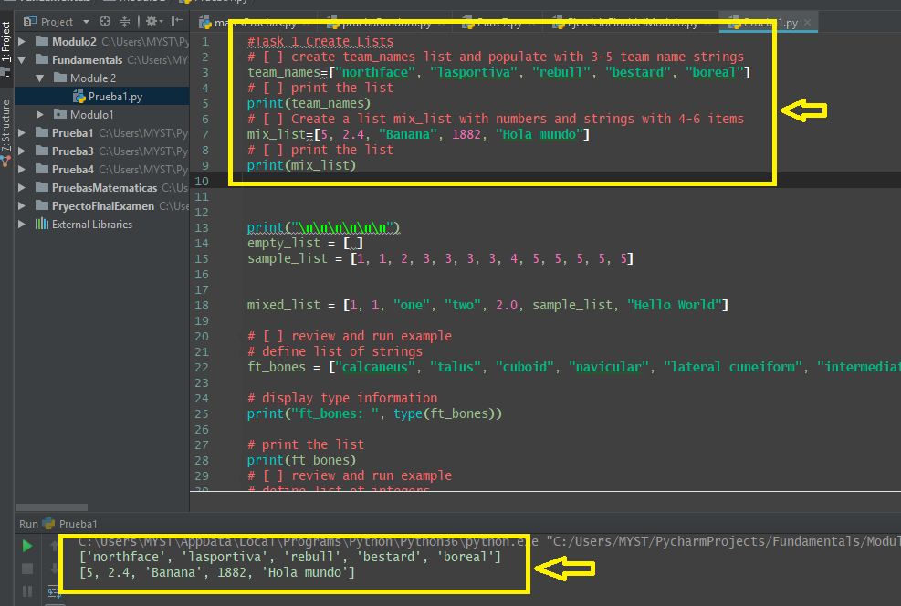

**1.3 Accessing Lists (List Access)**

**Video:** **AccessingListsV2.mp4**

**We can access objects in a list using the index.** Here in this first code cell we've defined ft_bones, a list that contains a number of strings. **Because lists are zero-based, the index 5 will be the sixth item in the list, as index 0 is the first item.** Running the code we see that we can print the sixth item in the list.

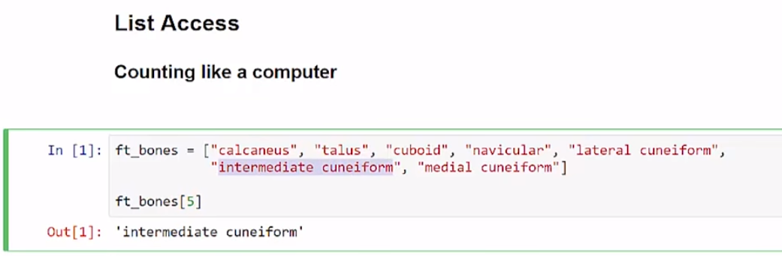

**Calling items by the index number follows the same properties as strings, where I can call item 0 is the first item and item -1 is the last item in the list.** And then I can count down from there. So let's go ahead and look at that code, and we see that we get our first item, at index 0, and our third item is at index 2, and the last item is shown at negative 1.

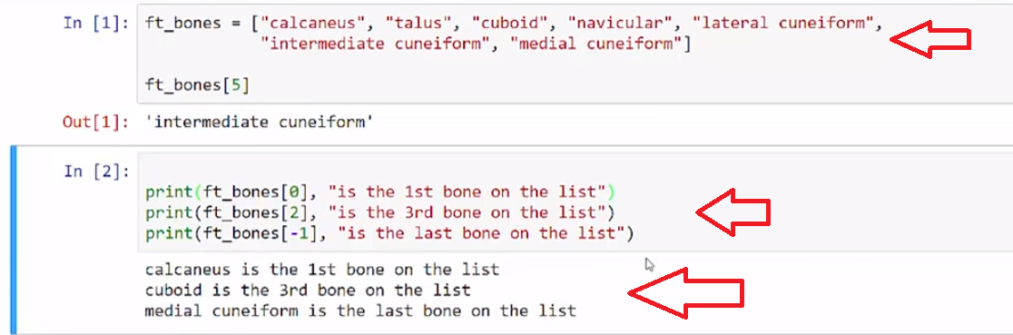

**We can use these list items with string methods such as title, because this is a list of strings. If it was a list of integers, then I would have to use integer properties with it**, but let's look at that code. And so, we can just build a sentence by calling specific items from the list.

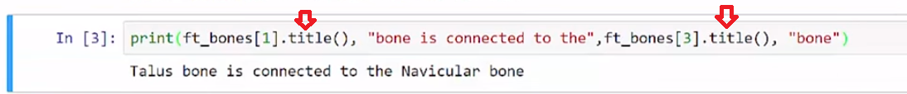

Here, working with integers in age_survey list. We can call the first item, the second item in 1 and the third item in 2 and build a sum of that, **because these items are integers, we can do mathematical summing.**

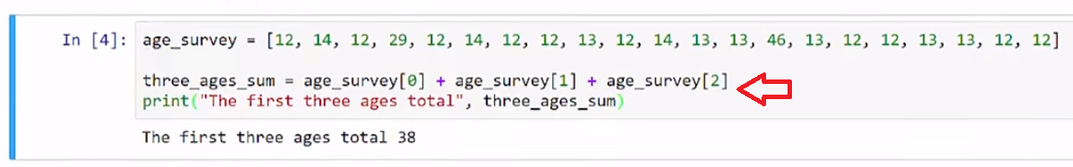

We access items in a list from the 0 index, for the first item, counting forward, and we can also count backwards using negative indexes to get the last item in a list.

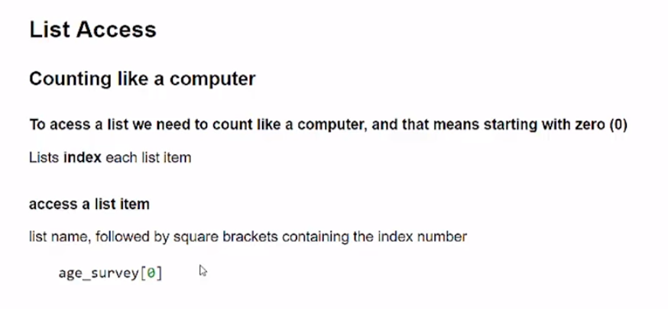

# Concept

## **List Access**

### Counting like a computer

#### To access a list we need to count like a computer, and that means starting with zero (0)

Lists give an **index** number to each list item

* first element in a list is index 0
* second element in a list is index 1

To access the first item in a list use the list name, followed by square brackets containing the index number

age_survey[0]

## **Examples**

|  |
| --- |
| **run previous examples before running the examples below** |
|  |

# [ ] review and run example

print(ft_bones[0], "is the 1st bone on the list")

print(ft_bones[2], "is the 3rd bone on the list")

print(ft_bones[-1], "is the last bone on the list")

# [ ] review and run example

print(ft_bones[1], "is connected to the",ft_bones[3])

# [ ] review and run example

three_ages_sum = age_survey[0] + age_survey[1] + age_survey[2]

print("The first three ages total", three_ages_sum)

## **Task 2**

# [ ] Create a list, streets, that lists the name of 5 street name strings

# [ ] print a message that there is "No Parking" on index 0 or index 4 streets

# [ ] Create a list, num_2_add, made of 5 different numbers between 0 - 25

# [ ] print the sum of the numbers

## **Task 3**

## **Fix the Errors**

# [ ] Review & Run, but ***Do Not Edit*** this code cell

# [ ] Fix the error by only editing and running the block below

print(" Total of checks 3 & 4 = $", pay_checks[2] + pay_checks[3])

# [ ] Fix the error above by creating and running code in this cell

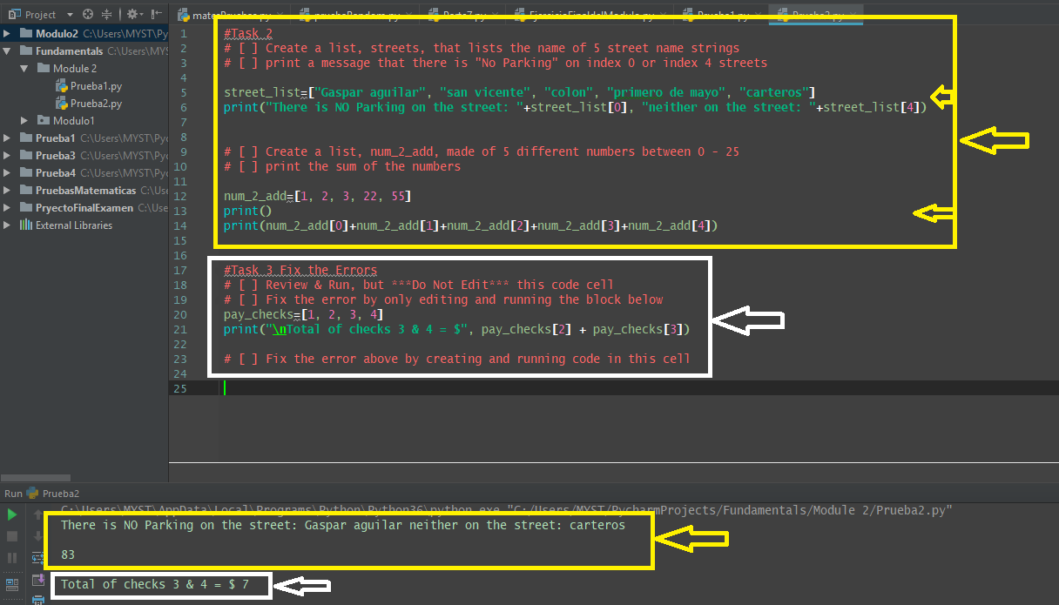

**1.4 Self-Check: Module 2: Lesson 2.1**

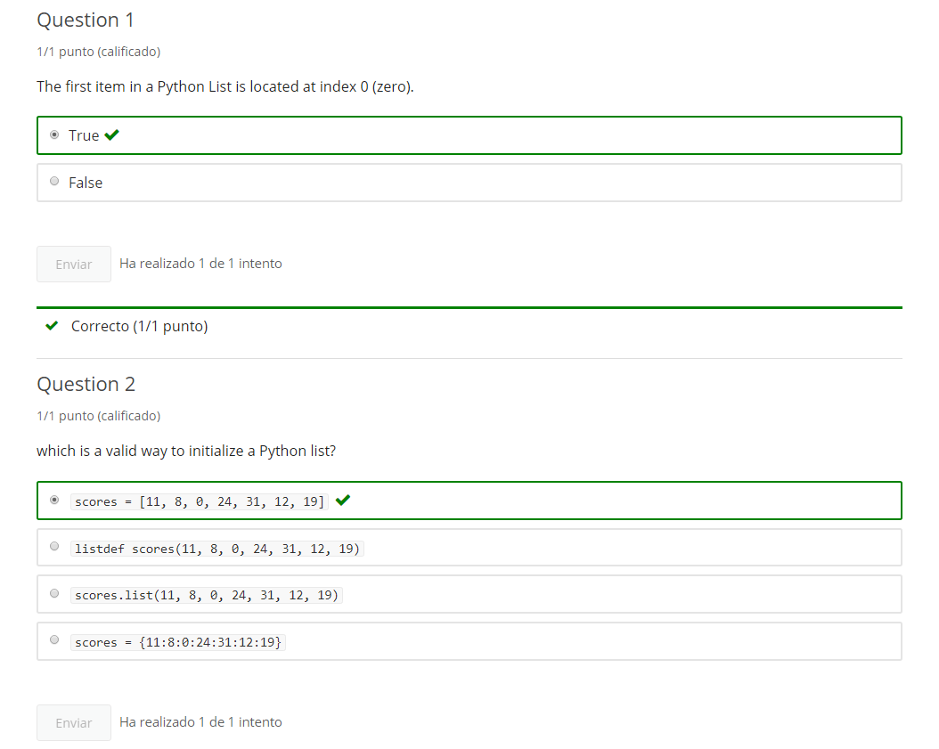

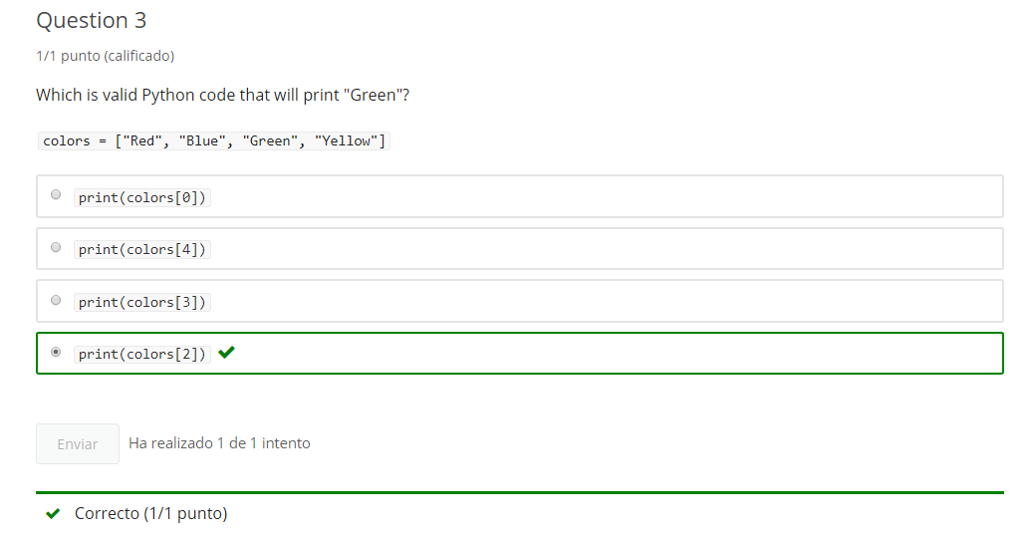

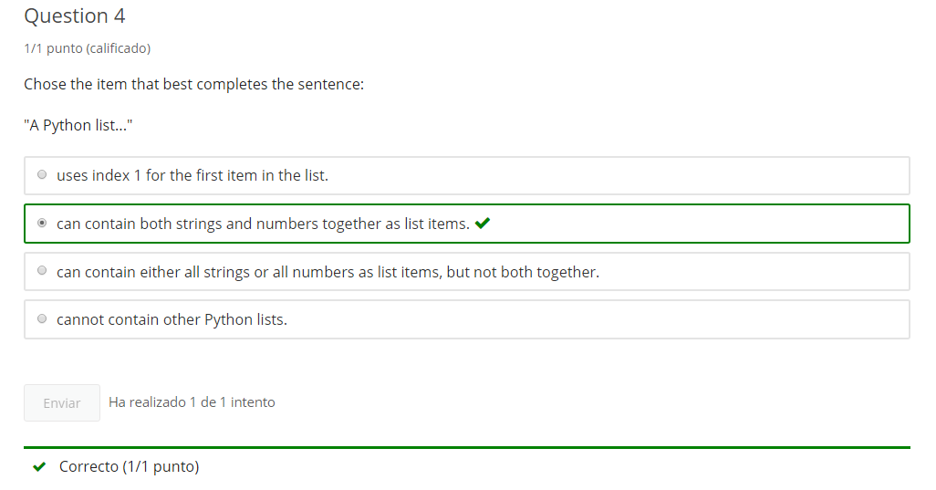

**2. List Append**

**2.1 Intro Python**

Jupyter Notebook: Mod2_2-2.2_Intro_Python.ipynb

## **Lists**

* List Creation
* List Access
* **List Append**
* List Insert
* List Delete

# Student will be able to

* **Add Items to the end of a list**

**2.2 Appending to a List**

**Video:** **AppendingToListV3.mp4**

**Lists can be extended adding to the end using the append method.** **Here we create a sample list that has three integers, and we wanna make it longer, so we're gonna use the .append() method. The way to use that is to add the item to append inside the parentheses.** Let's run that cell. And we see our initial list is further lengthened by **adding the 3 integer** **which we appended**.

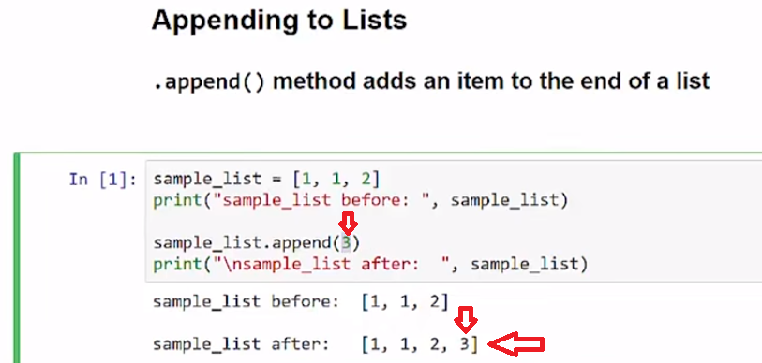

**We can add multiple items, just keep appending again and again. So here I'm going to append another 3, then an 8, then a 5 and in between we'll print that list.** So, let's run that code. We see the list we started with above and then our 3 is added, the 8 is added and the 5 is added. This is the current state of the sample list.

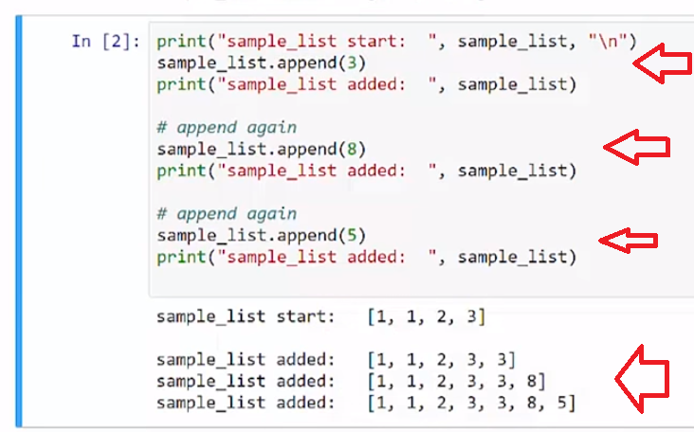

**Let's run the code again. Now, the sample list that we had added with last time we ran this cell, is the starting point. And then the 3, the 8, the 5 are added again.**

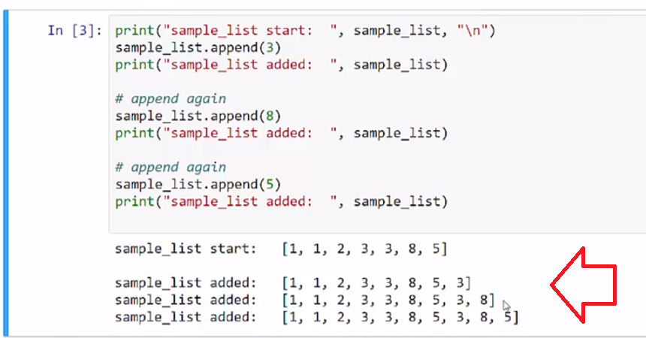

This can be repeated again and again and again.

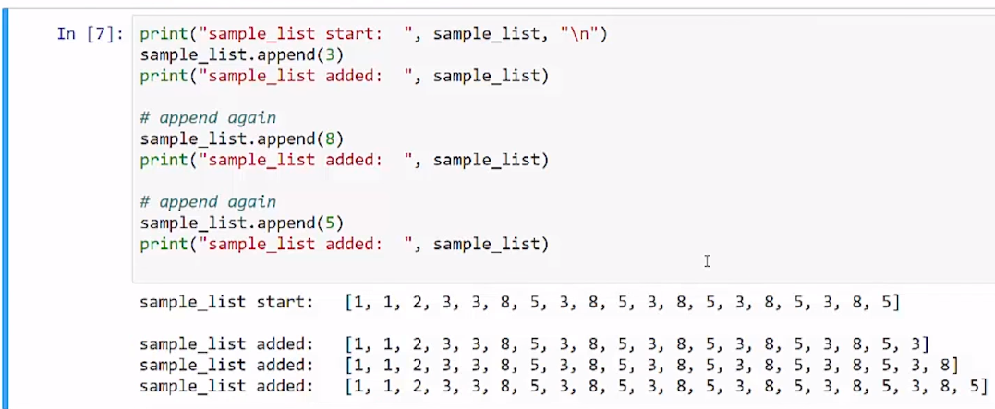

I'm going to reset my list by initializing with the 1, 1, 2 integer series.

This is an example of a mixed type list with a integer and a string. And I can append both integers and strings. So, let's look at that and we see that I was able to add a 3, and then I could add the string "turtle".

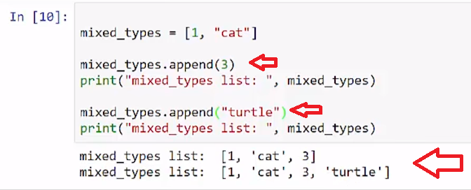

We can append to list using the append methods and it adds items at the end of a list regardless of the type of object.

**.append()** method adds an item to the end of a list

party_list.append("Alton")

## **Examples**

# [ ] review and run example

# the list before append

sample_list = [1, 1, 2]

print("sample_list before: ", sample_list)

sample_list.append(3)

# the list after append

print("sample_list after: ", sample_list)

# [ ] review and run example

# append number to sample_list

print("sample_list start: ", sample_list)

sample_list.append(3)

print("sample_list added: ", sample_list)

# append again

sample_list.append(8)

print("sample_list added: ", sample_list)

# append again

sample_list.append(5)

print("sample_list added: ", sample_list)

# [ ] run this cell several times in a row

# [ ] run cell above, then run this cell again

# [ ] review and run example

mixed_types = [1, "cat"]

# append number

mixed_types.append(3)

print("mixed_types list: ", mixed_types)

# append string

mixed_types.append("turtle")

print("mixed_types list: ", mixed_types)

## **Task 1**

## **.append()**

# Currency Values

# [ ] create a list of 3 or more currency denomination values, cur_values

# cur_values, contains values of coins and paper bills (.01, .05, etc.)

# [ ] print the list

# [ ] append an item to the list and print the list

# Currency Names

# [ ] create a list of 3 or more currency denomination NAMES, cur_names

# cur_names contains the NAMES of coins and paper bills (penny, etc.)

# [ ] print the list

# [ ] append an item to the list and print the list

## **Task 2**

## **Append items to a list with input()**

# [ ] append additional values to the Currency Names list using input()

# [ ] print the appended list

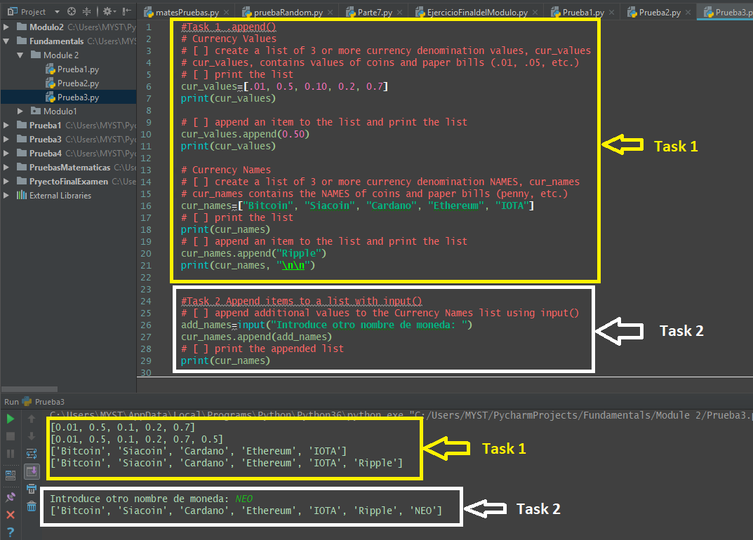**Task 3**

## **while loop .append()**

* define an empty list: **bday_survey**
* get user input, **bday**, asking for the day of the month they were born (1-31) or "q" to finish
* using a **while** loop (while user not entering "quit")
  + append the **bday** input to the **bday_survey** list
  + get user input, **bday**, asking for the day of the month they were born (1-31) or "q" to finish
* print bday_survey list

# [ ] complete the Birthday Survey task above

## **Task 4**

## **Fix The Error**

# [ ] Fix the Error

three_numbers = [1, 1, 2]

print("an item in the list is: ", three_numbers[3])

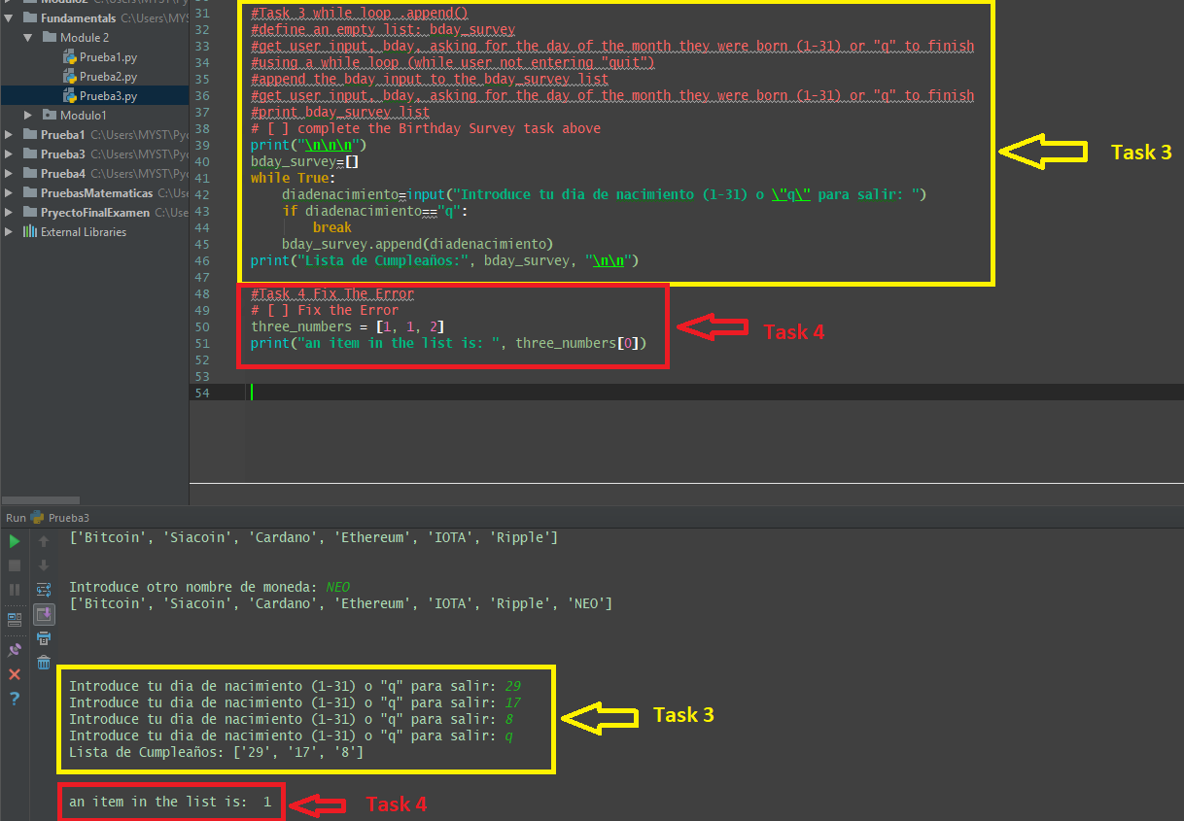

**2.3 Self-Check: Module 2: Lesson 2.2**

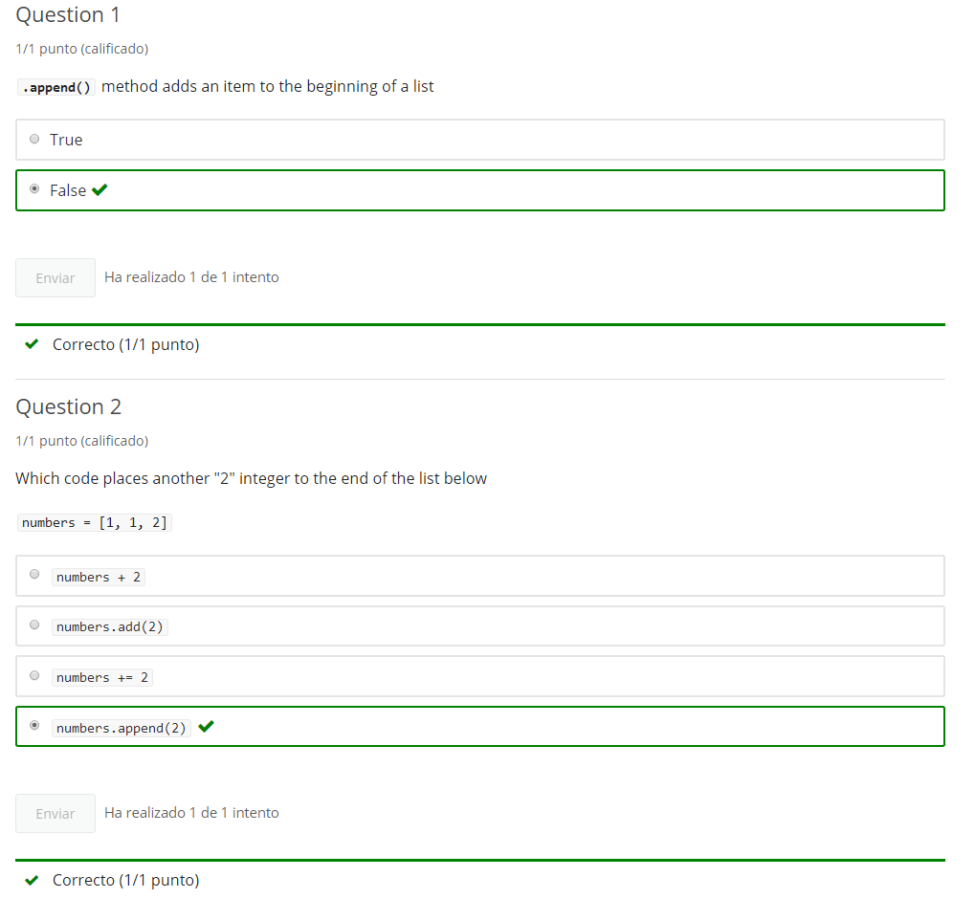

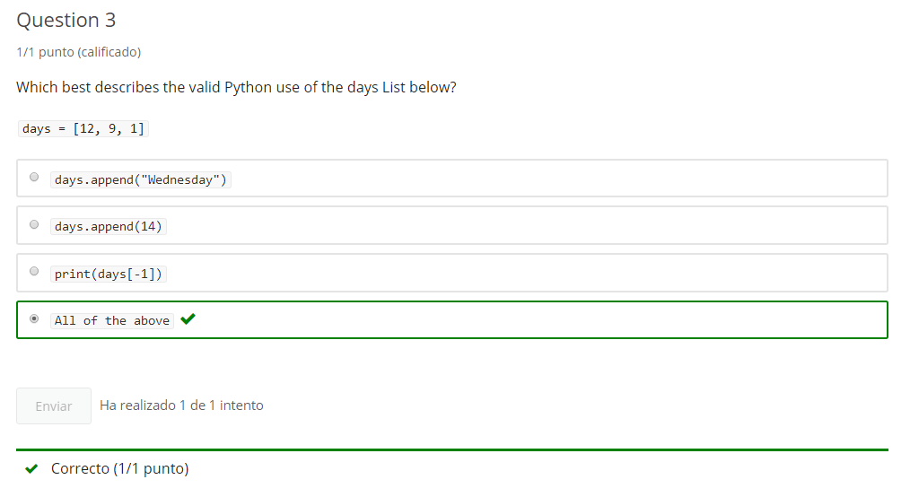

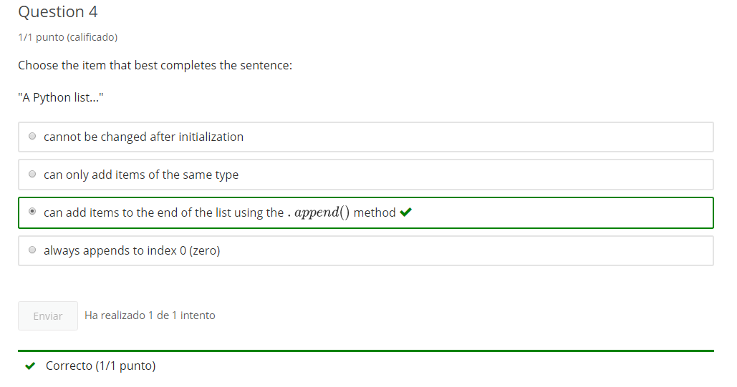

**3. List Insert**

**3.1 Intro Python**

Jupyter Notebook: Mod2_2-2.3_Intro_Python.ipynb

## **Lists**

* List Creation
* List Access
* List Append
* **List modify and Insert**
* List Delete

# Student will be able to

* **Modify and insert items into a list**

**3.2 Replace Value (Insert a new value for an index)**

**Video:** **ReplaceValueV4.mp4**

**We can replace items in a list by addressing the index.** In this example, we've created a list called party_list. It has a list of strings of names of people invited to the party. **We can reassign a index counting at index zero. Index one is "Alton", and we can reassign that, we can overwrite "Alton" with "Colette".** And so we can see the party_list before and the party list after. So, we see that before we had "Alton" in the second position, and now "Colette" has replaced that. **So using a string index, we can replace whatever's in the currentindex location.**

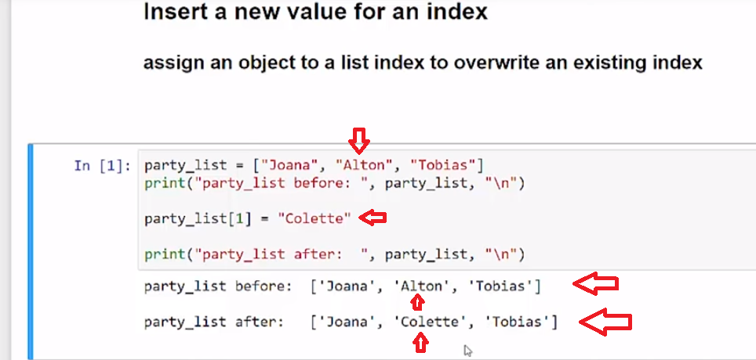

**In this example, we will add to the index item. So at list index 1, which is the second item, "Alton", we're going to add the string "Derosa". And so party_list[1] is equal to itself plus this additional string.** And then we can see when we run that, that we are modifying it in place. So we're basically overwriting with "Alton" with "Alton" plus "Derosa". The list contains three items at this point.

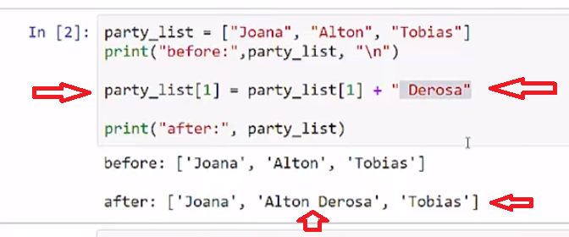

**And in this cell, we are trying tomodify the item at index number 3. And running that we get an index error out of range with zero, one, and two indexes, there is no three**, and we cannot use this assignment as an append it will error, you can only address existing list items.

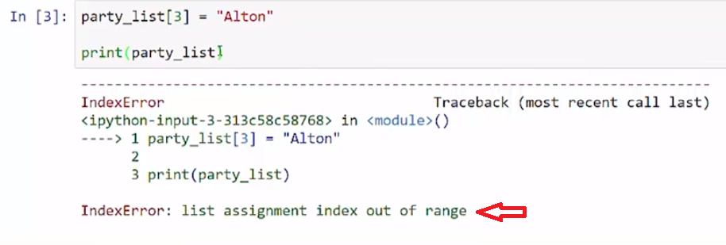

**In this final example, we have a single digits list which is a list of strings. And we're gonna look at the type of that string here by looking at the index three**, or the fourth item, which is right here, this is index three. **And then later, we're going to overwrite index 3 with the integer 3, and we'll look at the type afterwards.** So let's run that code. So, we see that three is class string, and that's right there. **And then we have the 3 overwrite that we did right here and that is a integer, so we can replace items of a different object type.**

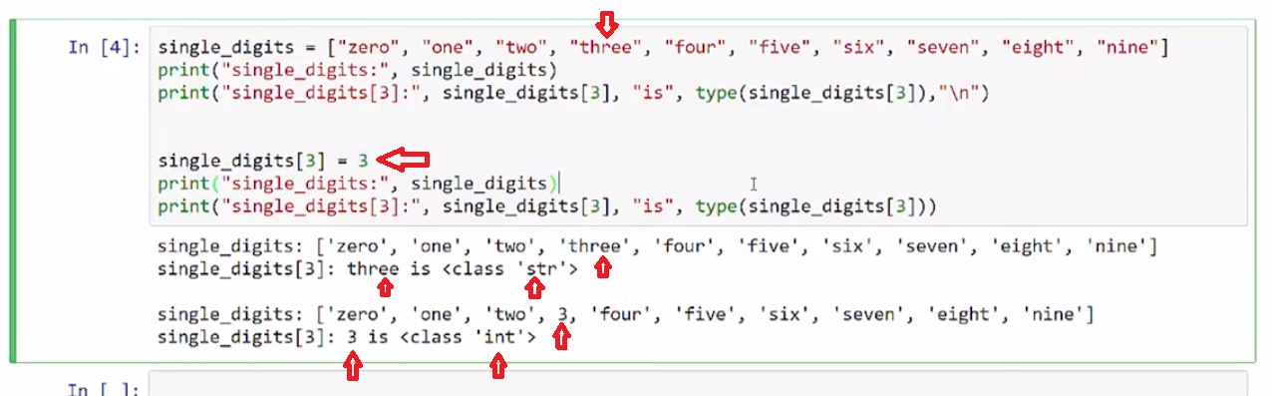

We can use the index assignment to update items in our list.

## **Concept**

## **Insert a new value for an index**

### overwrite a specific index in a list

party_list[2] = "Tobias"

* **Overwrites** existing index
* **Cannot** use to **Append** a new index to the list

## **Examples**

# [ ] review and run example

# the list before Insert

party_list = ["Joana", "Alton", "Tobias"]

print("party_list before: ", party_list)

# the list after Insert

party_list[1] = "Colette"

print("party_list after: ", party_list)

# [ ] review and run example

party_list = ["Joana", "Alton", "Tobias"]

print("before:",party_list)

# modify index value

party_list[1] = party_list[1] + " Derosa"

print("\nafter:", party_list)

### Example

**IndexError**

# IndexError Example

# [ ] review and run example which results in an IndexError

# if result is NameError run cell above before running this cell

# IndexError trying to append to end of list

party_list[3] = "Alton"

print(party_list)

# [ ] review and run example changes the data type of an element

# replace a string with a number (int)

single_digits = ["zero", "one", "two", "three", "four", "five", "six", "seven", "eight", "nine"]

print("single_digits: ", single_digits)

print("single_digits[3]: ", single_digits[3], type(single_digits[3]),"\n")

# replace string with an int

single_digits[3] = 3

print("single_digits: ", single_digits)

print("single_digits[3]: ", single_digits[3], type(single_digits[3]))

## **Task 1**

## **replace items in a list**

* create a list, **three_num**, containing 3 single digit integers
* print three_num
* check if index 0 value is < 5
  + if < 5 , replace index 0 with a string: "small"
  + else, replace index 0 with a string: "large"
* print three_num

# [ ] complete "replace items in a list" task

## **Function Challenge: create replacement function**

* Create a function, **str_replace**, that takes 2 arguments: int_list and index
  + int_list is a list of single digit integers
  + index is the index that will be checked - such as with int_list[index]
* Function replicates purpose of task "replace items in a list" above and replaces an integer with a string "small" or "large"
* return int_list

Test the function!

# [ ] create challenge function

## 

## **Task 2**

## **modify items in a list**

* create a list, **three_words**, containing 3 different capitalized word stings
* print three_words
* modify the first item in three_words to uppercase
* modify the third item to swapcase
* print three_words

# [ ] complete coding task described above

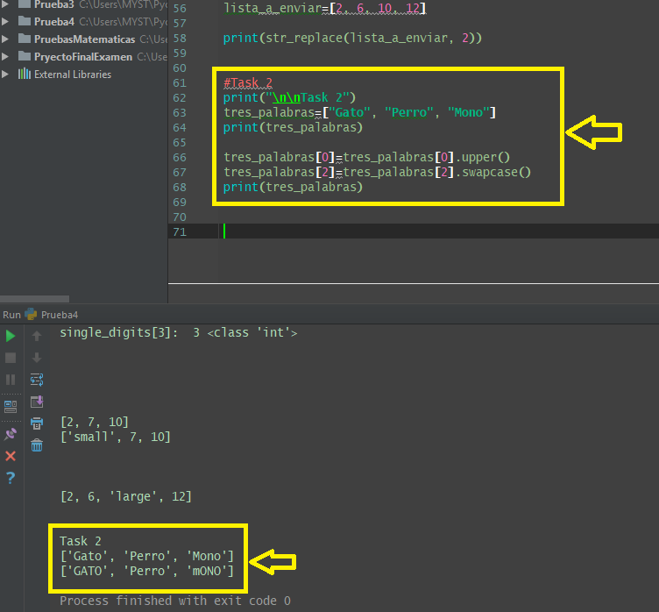

**3.3 Insert Value (Insert into a list)**

**Video:** **InsertValueV5.mp4**

**Items can be inserted into the middle of a list using the .insert() method.**

In our first example, we have party_list, which is a list of individuals who are invited to a party. And that list is a list of strings. And we're just gonna print out the party list, and we'll just print out some items to show where the index one and two is, and we'll do a insert in the cell below. So, we just see before we have "Joana", "Alton", "Tobias", 0, 1, 2 (index), so 1 is Alton, 2 is Tobias.

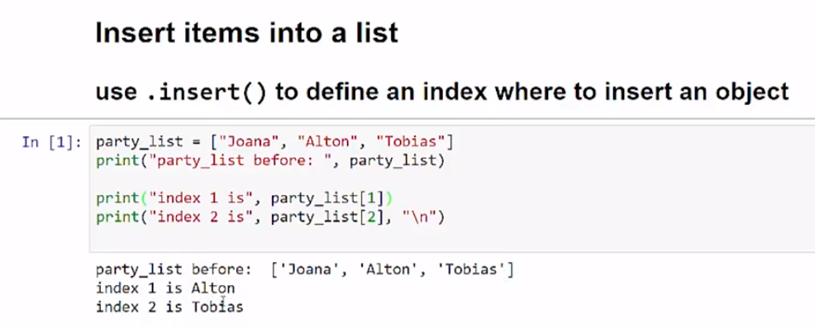

And look at this next cell where we are doing an insert. **The insert method for lists is the list name, followed by .insert() with parenthesis, and then, you give the index where you would like to insert an item, and the item to be inserted. So any object, it could be an integer, a string or other object.** Then below here, we're just going to print what it looks like after and then see what are in the 1 and 2 positions and 3 position just so we can compare that to above. So let's go ahead and run the code. **So we see that we've added "Colette" at 1, index 1, and Alton, which was at index 1, gets pushed up to index 2, and Tobias gets pushed to index 3**. So, we now went from a list of three items to a list of four items.

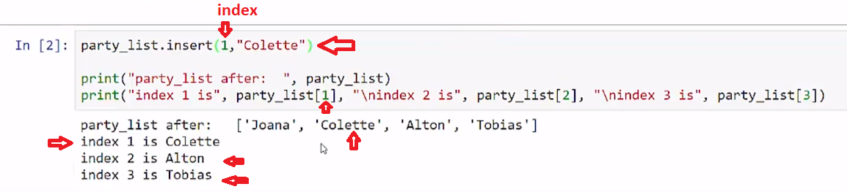

Over here, we're gonna use the insert to append an item. We can get that same effect as the append to add it to the end of the list. So we have the list has four items, so that's index 0, 1, 2, and Tobias is index 3, **so we're going to insert at index 4.** **And we see that before and the after list, we've added that "four" in there.**

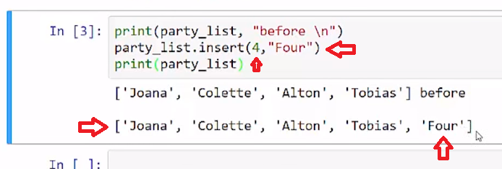

**And we can just put something way out there, a 10, even though there's nothing out there in between.** And we'll see that it just says, well, you must have meant the end of the list. **And so it just fills in that gap, even though there was no index for five, six, seven, eight and nine.** **And so now the 10 index, there is no item at index 10, it just defaulted back to five.**

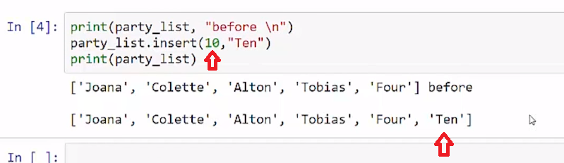

So we have seen that we can get a list and do a .insert method followed by parenthesis. And in those parenthesis, we put two items, the first item is the index location, and then a comma, and the second item is the object we'd like to insert. And we were doing strings here, but we can do any other object.

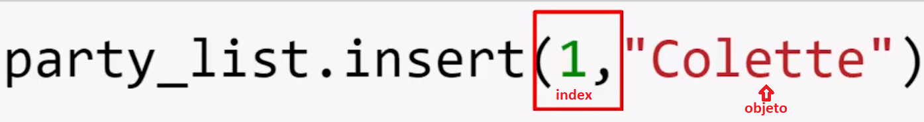

# Concept

## **Insert items into a list**

### use .insert() to define an index to insert an item

party_list.insert(2,"Tobias")

* Inserts, **doesn't overwrite**
* **Increases index by 1**, at and above the insertion point
* **Can** use to **Append** a new index to the end of the list

## **Examples**

# [ ] review and run example

# the list before Insert

party_list = ["Joana", "Alton", "Tobias"]

print("party_list before: ", party_list)

print("index 1 is", party_list[1], "\nindex 2 is", party_list[2], "\n")

# the list after Insert

party_list.insert(1,"Colette")

print("party_list after: ", party_list)

print("index 1 is", party_list[1], "\nindex 2 is", party_list[2], "\nindex 3 is", party_list[3])

## **Task 3**

## **insert() input into a list**

# [ ] insert a name from user input into the party_list in the second position (index 1)

party_list = ["Joana", "Alton", "Tobias"]

# [ ] print the updated list

## **Task 4**

## **Fix The Error**

# [ ] Fix the Error

tree_list = "oak"

print("tree_list before =", tree_list)

tree_list.insert(1,"pine")

print("tree_list after =", tree_list)

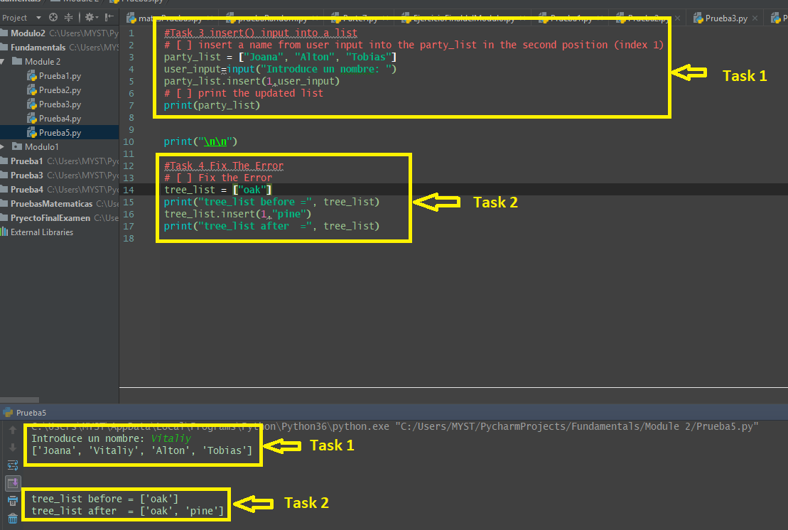

**3.4 Self-Check: Module 2: Lesson 2.3**

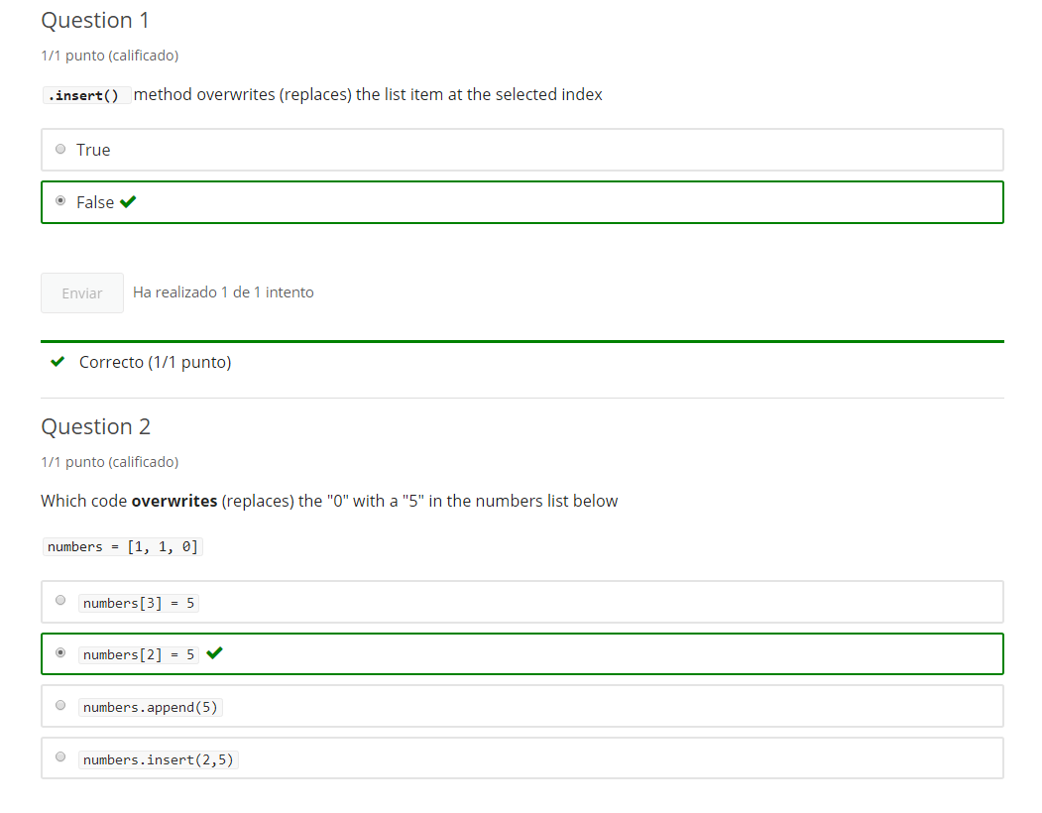

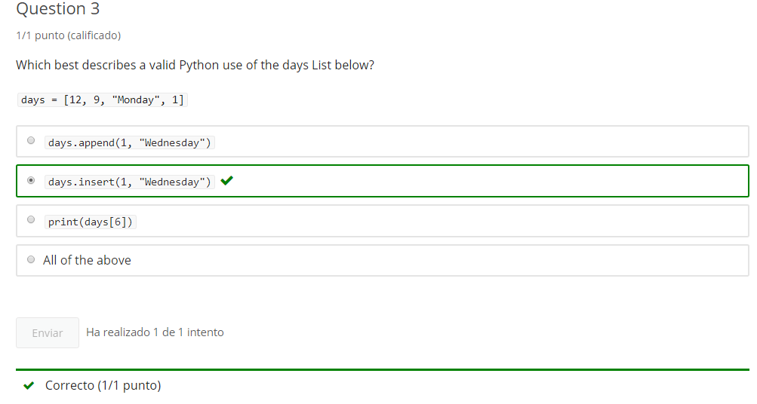

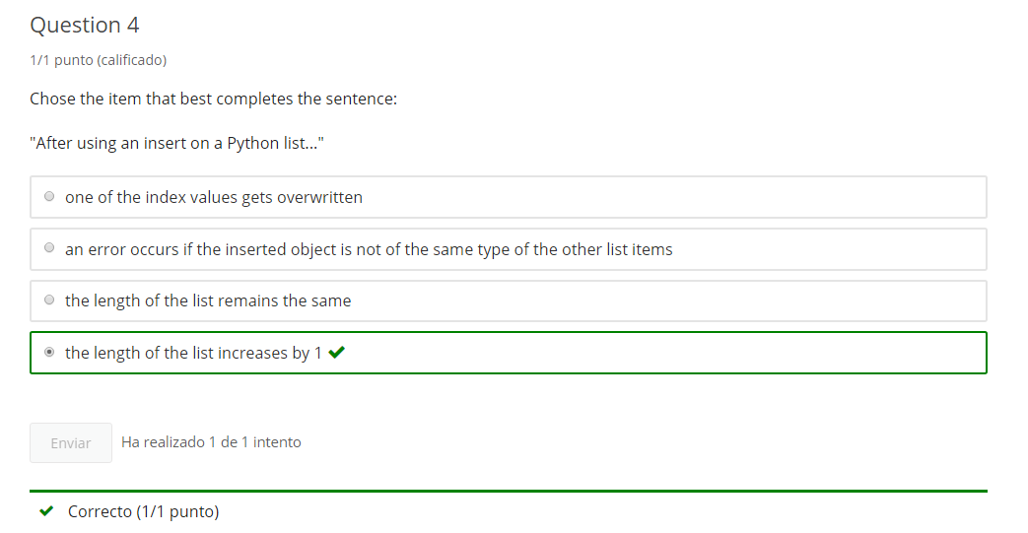

**4. List Delete**

**4.1 Intro Python**

Jupyter Notebook: Mod2_2-2.1_Intro_Python.ipynb

## **Lists**

* List Creation
* List Access
* List Append
* List Insert
* **List Delete (del, .pop() & .remove())**

# Student will be able to

* **Delete items from a list with del, .pop() & .remove()**

**4.2 Del Statement (Delete a specific List index)**

**Video:** **DelStatementV6.mp4**

**We can remove a specific item from a list using the delete command and the index.**

In our first code cell, we have sample_list and it has a list of integer items. So we can see that starting at index0, with 11 and then 21, 13, 14. So, we just have several integers in that list and we're gonna print out what it is before. And then, **we're going to use the delete command. And the delete command will follow with a specific list item. So in this case, we're going to delete the first Item in the list then we can see before and after that the first item "11" had been deleted.**

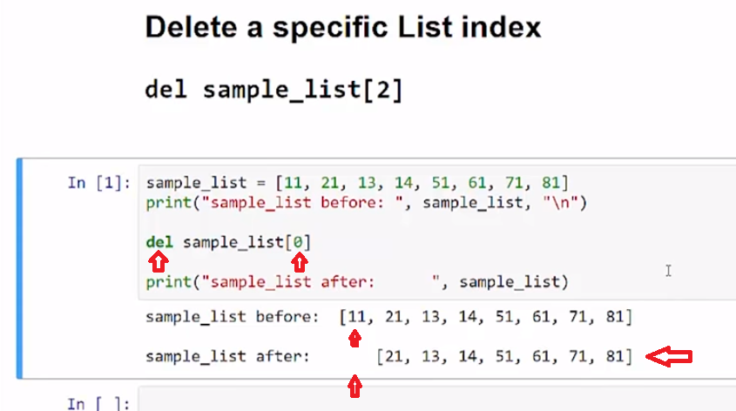

In our second example, **we're going to delete the last item in the list.** And so, we can see now that, initially the "81" was the last item and that has been deleted.

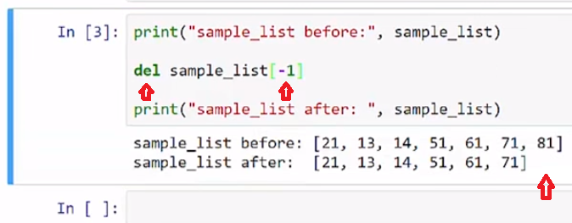

And of course, **you can delete items in the middle of the list as well**. And here we see that, the item "51" has been removed which is , (counting) zero, one, two, three.

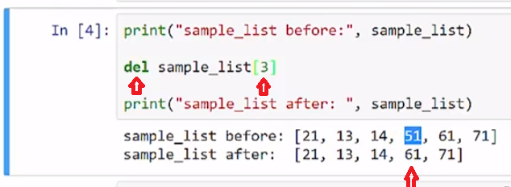

We can use the delete command, which is del, followed by a specific list index to delete items from a list.

# Concept

## **Delete a specific List index**

### del statement

del party_list[2]

## **Examples**

# [ ] review and run example

# the list before delete

sample_list = [11, 21, 13, 14, 51, 161, 117, 181]

print("sample_list before: ", sample_list)

del sample_list[1]

# the list after delete

print("sample_list after: ", sample_list)

# [ ] review and run example Multiple Times

# [ ] consider how to reset the list values?

print("sample_list before:", sample_list)

del sample_list[0]

print("sample_list after:", sample_list)

# [ ] review and run example

mixed_types = [1, "cat"]

# append number

mixed_types.append(3)

print("mixed_types list: ", mixed_types)

# append string

mixed_types.append("turtle")

print("mixed_types list: ", mixed_types)

## **Task 1**

## **del statement**

# [ ] print ft_bones list

# [ ] delete "cuboid" from ft_bones

# [ ] reprint list

ft_bones = ["calcaneus", "talus", "cuboid", "navicular", "lateral cuneiform",

"intermediate cuneiform", "medial cuneiform"]

## **Task 2**

## **multiple del statements**

# [ ] print ft_bones list

# [ ] delete "cuboid" from ft_bones

# [ ] delete "navicular" from list

# [ ] reprint list

# [ ] check for deletion of "cuboid" and "navicular"

ft_bones = ["calcaneus", "talus", "cuboid", "navicular", "lateral cuneiform",

"intermediate cuneiform", "medial cuneiform"]

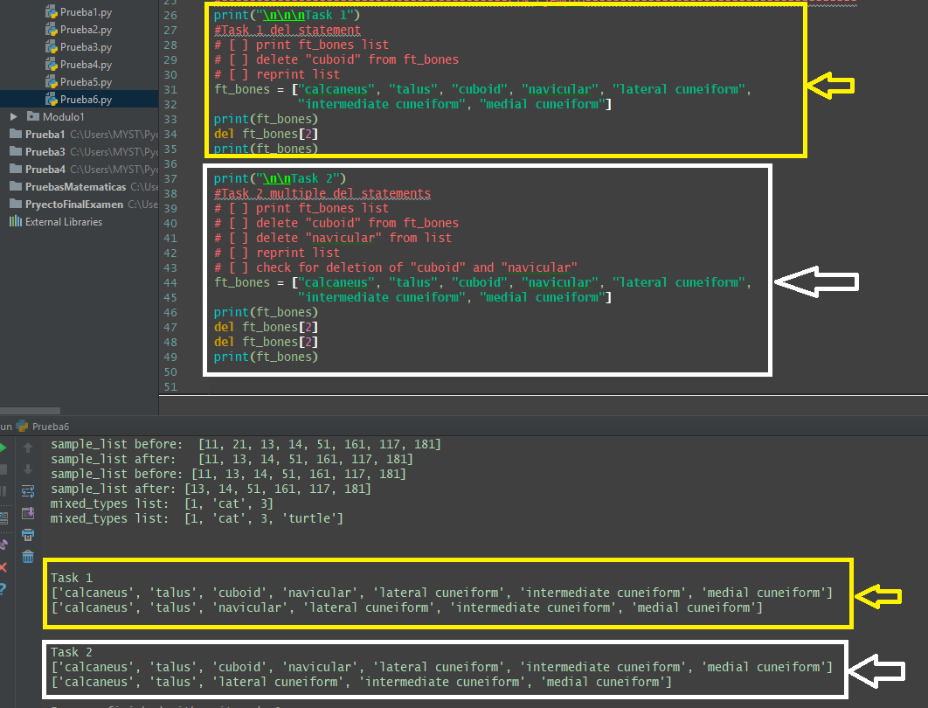

**4.3 .pop() (.pop() gets and deletes item in list)**

**Video:** **Pop()V7.mp4**

**We can both return a list item and remove that item from a list using the .pop() method.**

In our first cell, we have party_list with three attendees, string items in our list. We'll just print that list out there and then we're going to use the list pop method. **And, with the pop method, we'll do this, by default, if you put no index item in there, it will return the last item in the list. So in this case, Tobias and, it will remove the item from the list. So, it both returns and removes the item.** We're gonna run a three pops in a row and we'll welcome the people after we pop them, the string items. So let's go ahead and run that. So, we can see the results there. The list first pops "Tobias" and then, we print the list again and we see that "Tobias" is left. Then, we pop "Alton" then "Joana".

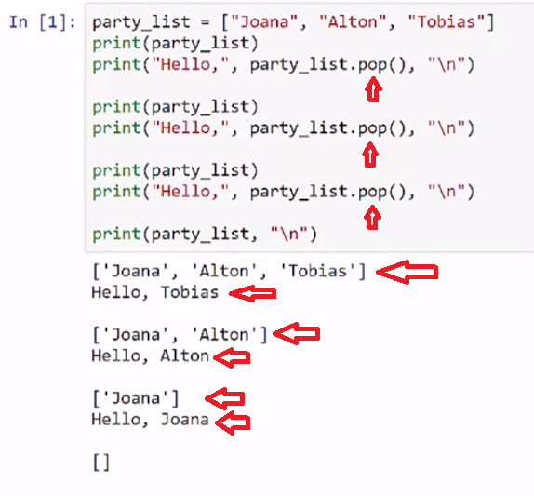

In our second example, **we have list of integers called number_list. And we're going to pop index three so, (counting) zero, one, two, three. And let's run that code and we see that, the 14 item is now removed from the list.** It will just pop, if we did not print it or otherwise display as we did in the previous example, where we had it in a print statement. So, it's just a way we can also use it as a delete.

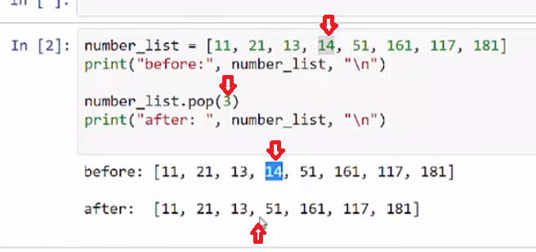

Again, with number_list in the final example**, we're going to, this time capture the pop in a variable called number_1 and number_2. So let's run that code. And we see that the items are removed from the end because we had no index value and then, we can take those numbers out. Since their list of items are return or objects, we use these integers that we returned or they were strings we could do string addition.** Or, other object manipulation but we're able to pull things from the list and work with them and that's a very valuable thing to do within our code.

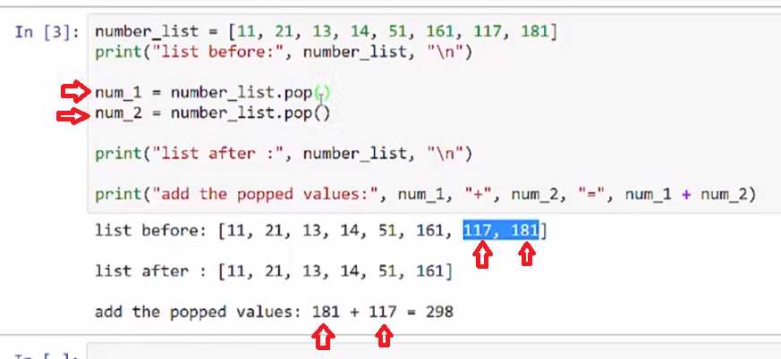

**So, we'll use the pop method by default. It returns the last item in the list and deletes it. If we supply a index item, it will return a specific index item and delete that item from the list.**

# Concept

## **.pop() gets and deletes item in list**

### .pop() method default is last item in a list

last_item = party_list.pop()

first_item = party_list.pop(0)

## **Examples**

# [ ] review and run example

# pop() gets the last item by default

party_list = ["Joana", "Alton", "Tobias"]

print(party_list)

print("Hello,", party_list.pop())

print("\n", party_list)

print("Hello,", party_list.pop())

print("\n", party_list)

print("Hello,", party_list.pop())

print("\n", party_list)

# [ ] review and run example

# can pop specific index like pop(3)

number_list = [11, 21, 13, 14, 51, 161, 117, 181]

print("before:", number_list)

number_list.pop(3)

print("after :", number_list)

# [ ] review and run example

# set a variable to a poped value

number_list = [11, 21, 13, 14, 51, 161, 117, 181]

print("list before:", number_list)

num_1 = number_list.pop()

num_2 = number_list.pop()

print("list after :", number_list)

print("add the popped values:", num_1, "+", num_2, "=", num_1 + num_2)

## **Task 3**

## **pop()**

# [ ] pop() and print the first and last items from the ft_bones list

ft_bones = ["calcaneus", "talus", "cuboid", "navicular", "lateral cuneiform","intermediate cuneiform", "medial cuneiform"]

# [ ] print the remaining list

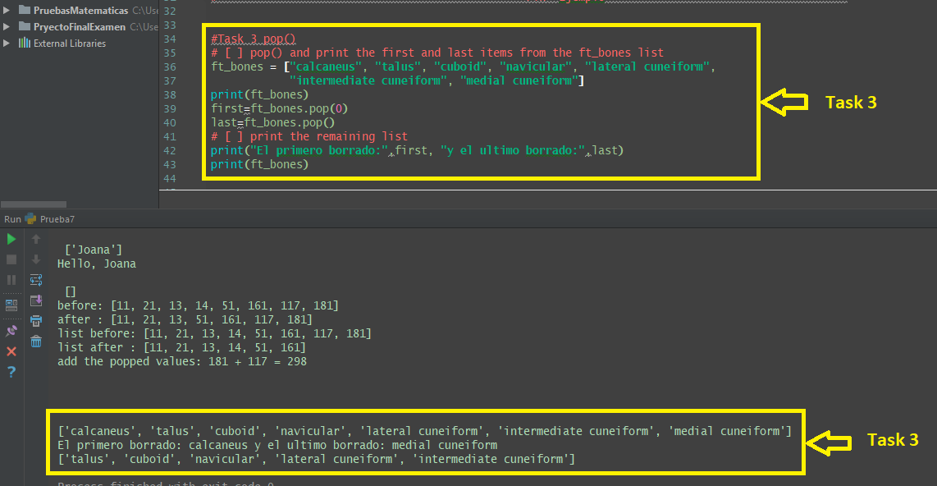

**4.4 empty list is False (an empty list is False)**

**Video:** **EmptyListIsFalseV8.mp4**

**We can use a list as a conditional flag. An empty list will return false, and a populated list will return true.** >> In our example, we've defined a list of strings called dog types, that has the name of three different dog breeds. >> **Then we print that out and when we use that list as the argument for a while loop. It turns out that once the list is empty, it stops running. That is exit criteria as the same as false. We can run popping items from the list and we'll print out the list as we go to see the list gets smaller until it's empty and then the loop will exit.** Let's run that code. Here we see their initial list with three items. Then Poodle is popped because the default pop is the last item. Then Pug is removed and finally Lab and we have an empty list. We can use a while loop that has a list as its argument and we're iterate through each item on the list if we pop items off and it will exit when the list is empty.

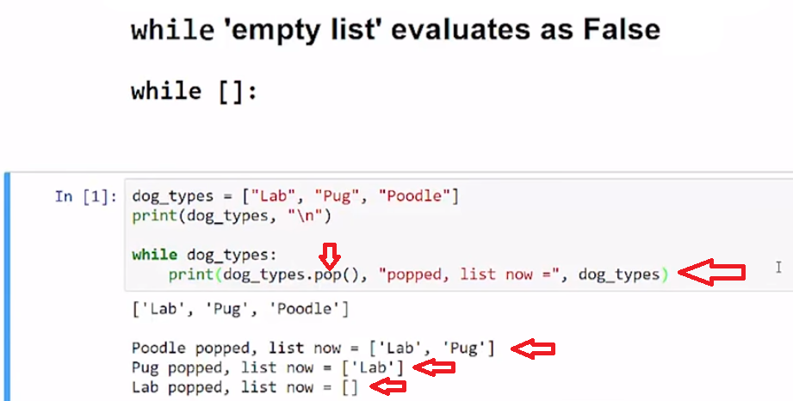

# Concept

## **an empty list is False**

### in a conditional an empty list will evaluate False

This allows creating a while loop that runs until a list is empty

while dog_types:

## **Example**

dog_types = ["Lab", "Pug", "Poodle"]

while dog_types:

print(dog_types.pop())

## **Task 4 pt 1**

# Cash Register Input

* create a empty list purchase_amounts
* populate the list with user input for the price of items
* continue adding to list with while until "done" is entered
  + can use while True: with break
* print purchase_amounts
* continue to pt 2

#[ ] complete the Register Input task above

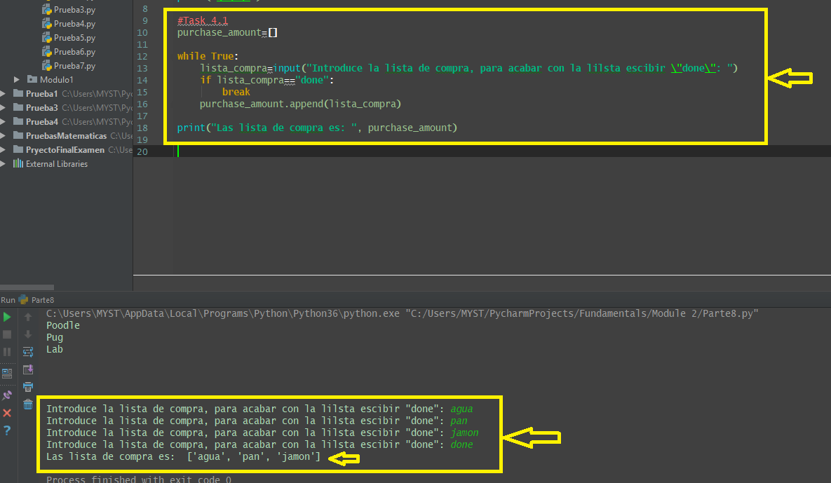

## **Task4 pt 2**

# Cash Register Total

* create a **subtotal** variable = 0  
  create a while loop that runs **while** purchase_amount (is not empty)
* inside the loop
  + **pop()** the last list value cast as a float type
  + add the float value to a **subtotal** variable
* after exiting the loop print **subtotal**

be sure to populate purchase_amounts by running pt 1 above

# [ ] complete the Register Total task above

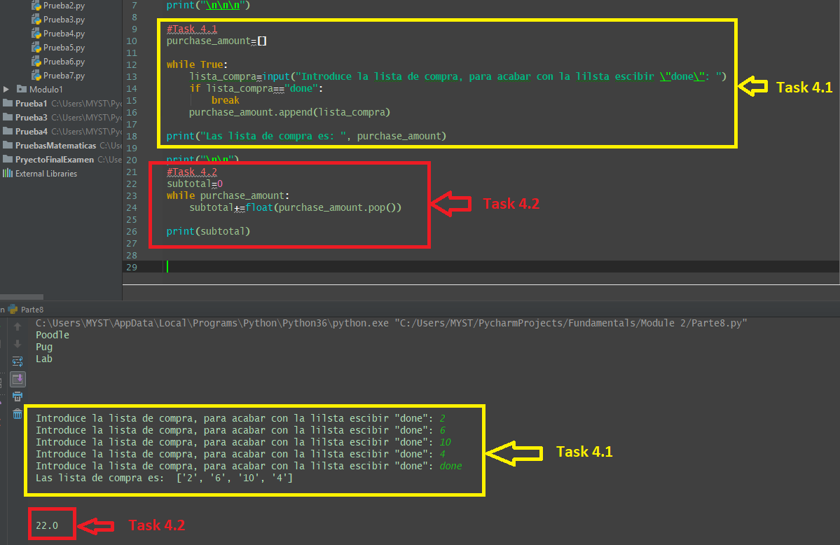

**4.5 .remove() [Delete a specific object from a list with .remove() ]**

**Video:** **Remove()V9.mp4**

**We can remove a specific object type from a list by using the remove method, and we don't need the index.**

In this first code cell, I just have a variable, dog_types, that's gonna be initialized as a list, has three strings "Lab", "Pug", and "Poodle". Let's run that code cell. Now that's in memory, so we're gonna look at this next cell. And I put dog_types, the definition of the list initiation, in a different cell because I wanna be able to run this cell more than once. **Because I want to see what happens after I remove "Pug", so first of all I'm gonna check is "Pug" in dog_types, and if it is I'm going to run this remove method, which is a list method. So to dog_types, the list remove, you type the word remove and parentheses, then, you put the object you want to remove inside, and it will search through your list and remove the first instance that it finds. And so, in this case, it would remove "Pug".** And then, if "Pug" is not in that list, then I have an else statement print ("No Pug found") and the reason I do that is because if I try to remove something that doesn't exist that is an error. So let's go ahead and run it, and this will print the before and after, so let's take a look. So before I have "Lab, "Pug", "Poodle", "Pug" gets removed because "Pug" is in dog_types.

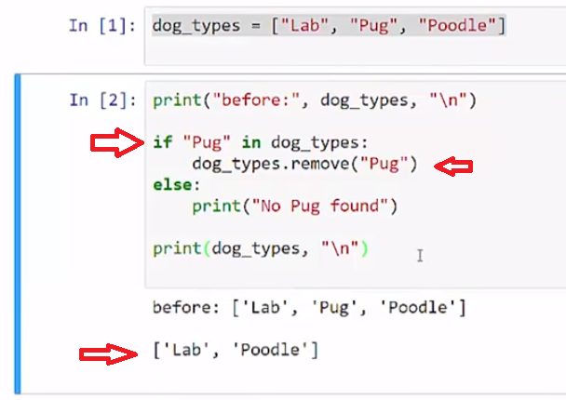

**I run it again, and it is "Lab" and "Poodle" and there's no "Pug", and so the message "no pug found" is displayed.**

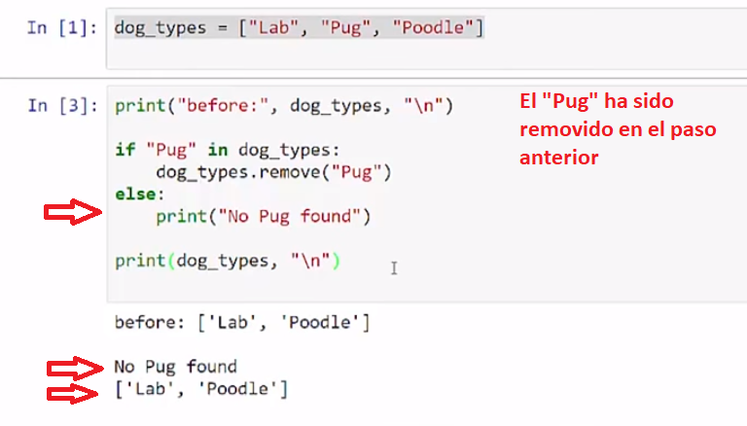

**In this next example here I have a longer list. It has "Poodle" listed several times in the list I'm going to use a while loop, while "Poodle" is found in the list "dogs". So whatever object I want to search for here, could be an integer or another object in the "dog" list, then I will do the remove. And again, the remove method works on a list, a period, the name remove. And then I have parentheses and the object that I wanna remove. I'll keep going through this list, and each time I will print what the list looks like**, so let's run that code. So we see that Poodle was removed, first time, the first instance. And then the second instance gets removed, and then the final instance gets removed. And at this point, when while poodle in dogs returns false, and that just ends the loop.

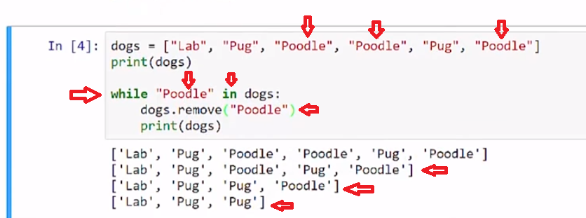

**So let's look at that error. If I try to remove something that doesn't exist in the loop, in this case, I'm going to try to remove Collie from the list dogs and it doesn't exist. We see that we get a ValueError. It says it is not in the list. So the item we searched for was not in the list, that causes an error.**

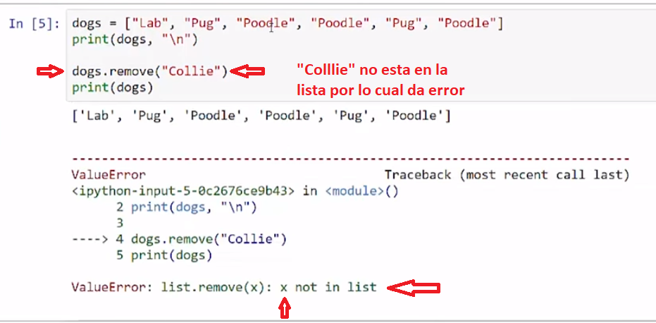

Use the .remove() to remove a specific named object from a list.

# Concept

## **Delete a specific object from a list with .remove()**

### .remove(object) removes the 1st item that matches

dog_types.remove("Pug")

**ValueError** occurs if the object is not available to be removed

## **Examples**

# [ ] review and run example

dog_types = ["Lab", "Pug", "Poodle"]

if "Pug" in dog_types:

dog_types.remove("Pug")

else:

print("no Pug found")

print(dog_types)

# [ ] review and run example

dogs = ["Lab", "Pug", "Poodle", "Poodle", "Pug", "Poodle"]

print(dogs)

while "Poodle" in dogs:

dogs.remove("Poodle")

print(dogs)

### ValueError

# [ ] review and run example

# Change to "Lab", etc... to fix error

dogs.remove("Collie")

print(dogs)

## **Task 5**

## **.remove()**

# [ ] remove one "Poodle" from the list: dogs , or print "no Poodle found"

# [ ] print list before and after

dogs = ["Lab", "Pug", "Poodle", "Poodle", "Pug", "Poodle"]

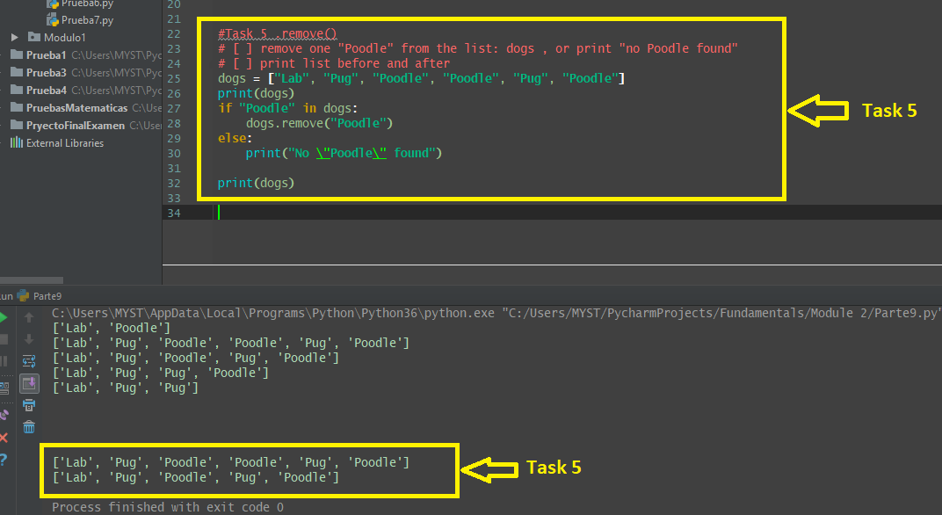

**4.6 Self-Check: Module 2: 2.4**

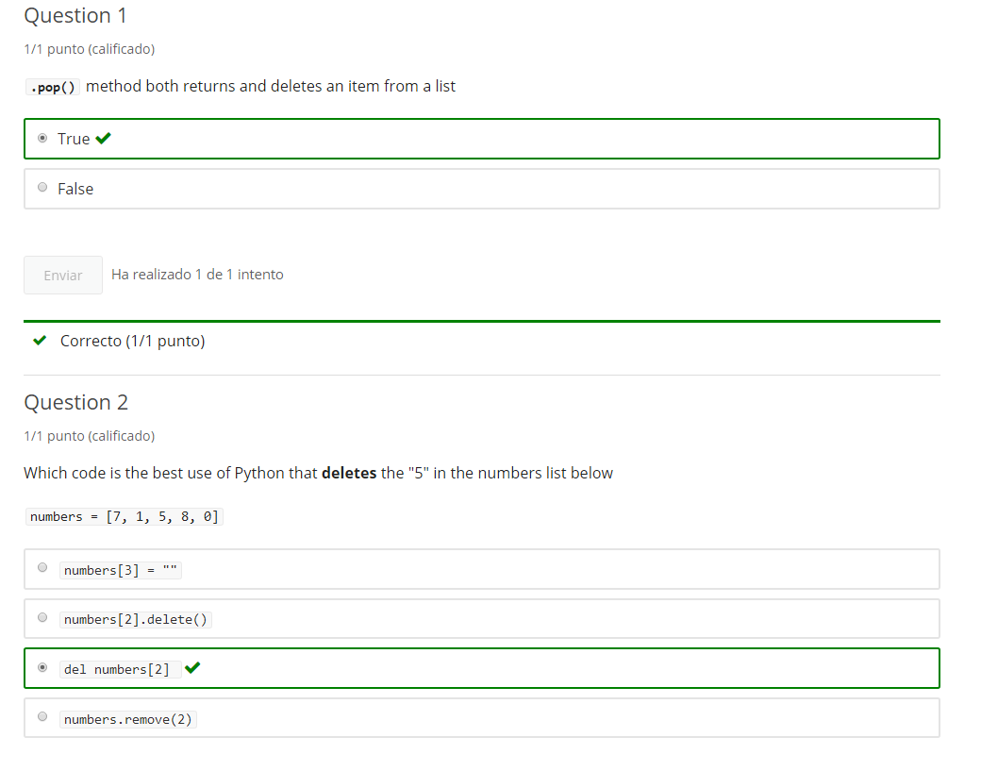

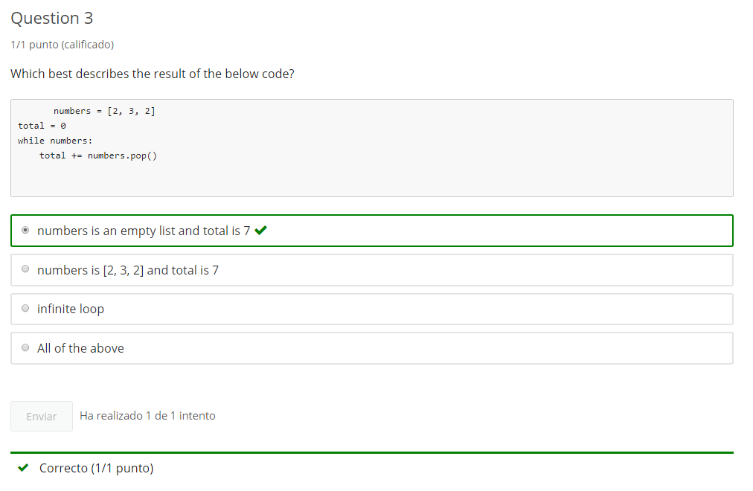

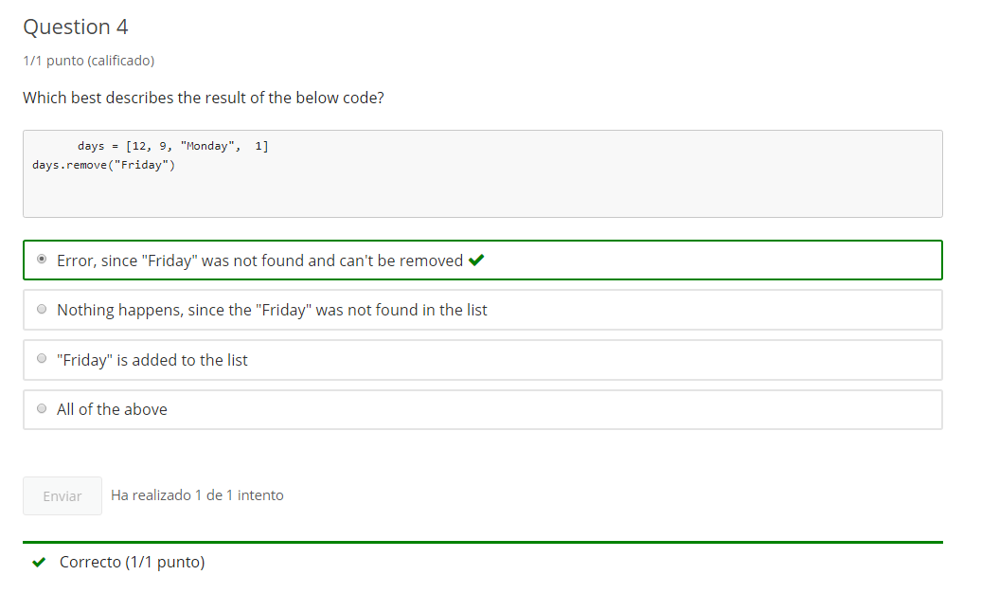

**5. Module 2 Practice**

Jupyter Notebook: Mod2_2-2_IntroPy_Practice.ipynb

## **Lists**

# Student will be able to

* Create Lists
* Access items in a list
* Add Items to the end of a list
* Insert items into a list
* Delete items from a list

## **Create Lists**

# [ ] create and populate list called days_of_week then print it

# [ ] after days_of_week is run above, print the days in the list at odd indexes 1,3,5

## **Phone letters**

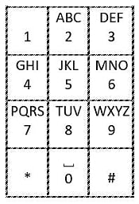

Create a list, **phone_letters**, where the index 0 - 9 contains the letters for keys 0 - 9.

* 0 = ' ' (a space)
* 1 = '' (empty)
* 2 = 'ABC'
* 3 = 'DEF'
* etc...

# [ ] create and populate list called phone_letters then print it

## **Access Lists**

### for the 2 cells below

* Use days_of_week list created above
* Run the cell above to make the list available

# [ ] create a variable: day, assign day to "Tuesday" using days_of_week[]

# [ ] print day variable

# PART 2

# [ ] assign day to days_of_week index = 5

# [ ] print day

## **Append and Insert items into a list**

### Endsday, Midsday, Resterday

#### for the exercises below

* Use days_of_week list created above
* Run the cell defining days_of_week above to make the list available

# [ ] Make up a new day! - append an 8th day of the week to days_of_week

# [ ] print days_of_week

### Question

* What happens if you keep running the cell above?
* How can you return to the initial state with the regular 7 days in days_of_week?

# [ ] Make up another new day - insert a new day into the middle of days_of_week between Wed - Thurs

# [ ] print days_of_week

# [ ] Extend the weekend - insert a day between Fri & Sat in the days_of_week list

# [ ] print days_of_week

## **Delete from a list**

### del & .pop() some bad ideas

#### exercises below assume days_of_week appended/inserted 3 extra days in previous exercises

# [ ] print days_of_week

# [ ] modified week is too long - pop() the last index of days_of_week & print .pop() value

# [ ] print days_of_week

# [ ] print days_of_week

# [ ] delete (del) the new day added to the middle of the week

# [ ] print days_of_week

# [ ] print days_of_week

# [ ] programmers choice - pop() any day in days_of week & print .pop() value

# [ ] print days_of_week

## **Program: Letter to Number Function**

### for the exercise below

* Use phone_letters list created above
* Run the cell above to make the list available

#### recall unit 1 using in to search for a string in a string

if "e" in "open":

print("e found")

else:

print("e not found")



### create function let_to_num()

* let_to_num() takes input of a single letter, space or empty string stored in an argument variable: letter
  + use while key < 10: to try numbers 0 - 9 as index for phone_letters ("key" = phone dial pad key)
  + check if letter variable is in the index of phone_letters[key]

key = 0

while key < 10:

if # Create Code: determine if letter is **`in`** any of the phone_letters[key] where key is the index 0 -9:

return key

else:

key = key + 1

return "Not Found"

* return the number or "Not Found"
* **call** let_to_num() to test the function so it prints the argument and return value with:
  + space
  + lowercase letter
  + different letter, uppercase
  + a number

**Bonus**: create a special case to check if empty string ("") was submitted  
the problem is that an empty string will be found in all strings as

if "" in "ABC":

is True, and is true for any phone_letters, but should return 1

# [ ] create let_to_num()

## **Challenge: reverse a string**

### using

* while
* .pop()
* insert()

**pop()** the **first item** in the list and add to the beginning of a new string that will be reversed

# [ ] Challenge: write the code for "reverse a string" reversing some_numbers

some_numbers =[1,2,3,4,5,6,7,8,9,11,22,33,44,55,66,77]

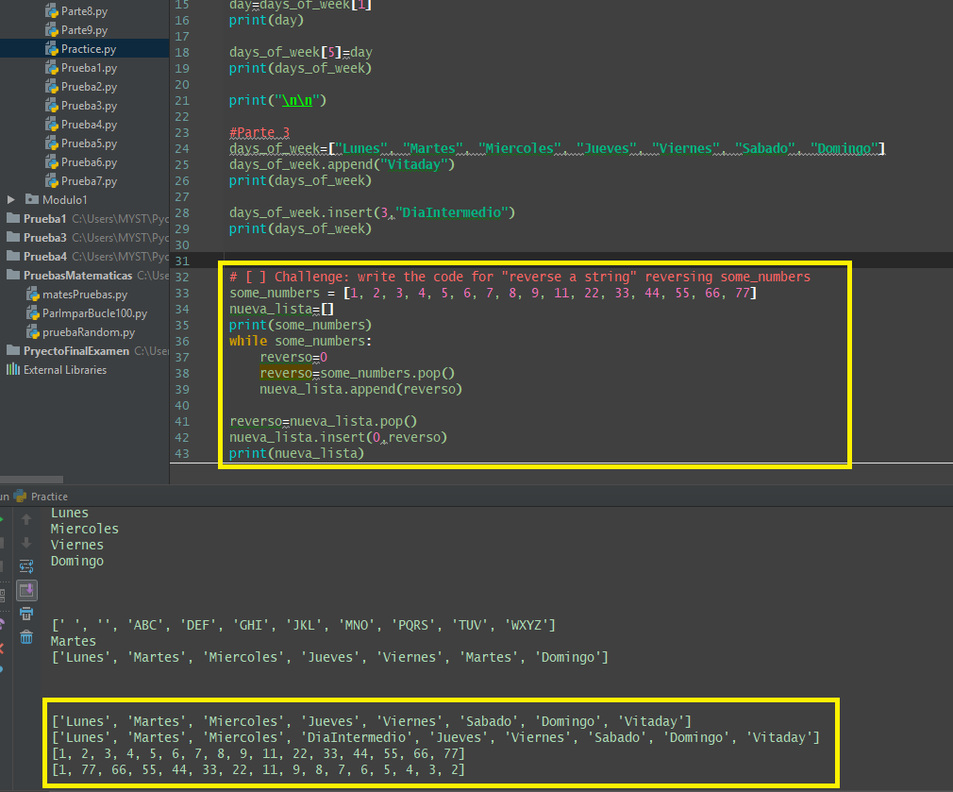

**End of Mod coding Assignment**

# Module 2 Required Coding Activity

**Video:** **RequiredCodeDescriptionV10.mp4**

We've made it to module two's Required Coding Activity, and now we get to build the list-o-matic. We're here on the index page, and we can see that there is a flowchart that helps describe the problem. There are two different parts of flowchart: The main body of the program, and the list_o_matic Function, that will add and remove items to our list.

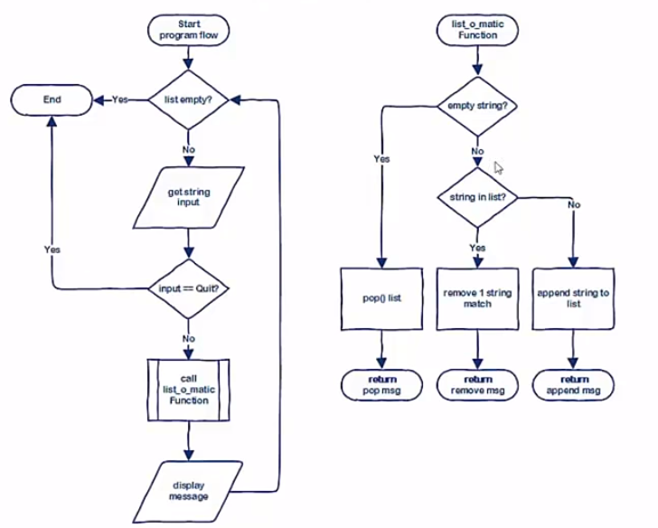

Let's just start off and take a look at the Jupyter Notebook. It has that same information. We can run the program and just see what it looks like. I've preloaded some code here. So let's go ahead and just run to see what the program looks like when it's running. So we're going to enter the name of the animal and it shows us all the animals that we currently have. If I add the name of a animal that exists in the list, it will remove it. And if I add a new name, then it will add to the list. So I'm going to add dog. And then we see that dog is added to the list, and we have two cats on there, so I'm going to add cat again, and we see that it removes the cat and continues to remove a cat, and then I can quit.

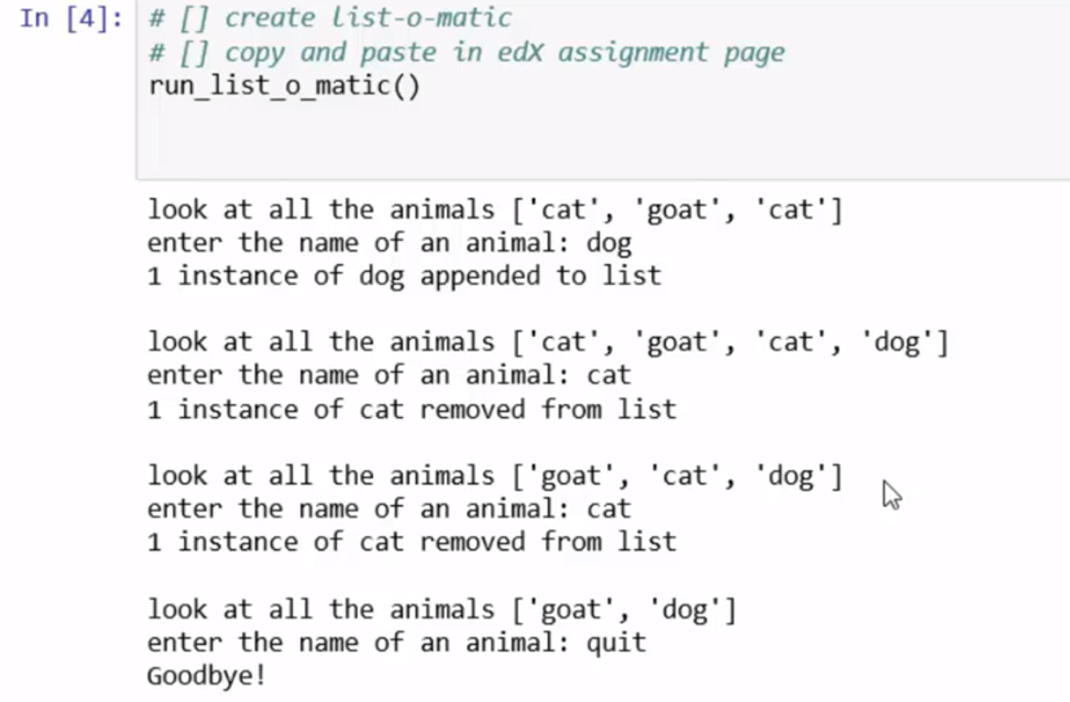

Back to the index page, looking at the flow chart, we can see there's the main body of the program. It starts at the top here, it says is a list empty? So, somehow we're starting with the list, and so we're going to have to pass a list and then check if that list is empty or not. And if it's empty then the program's done, and we exit the same as if we write quit for input. If it's not, then we get our string input. So we looked in there if I wrote cat and I had cat in the list, then we're going to do that thing where we remove it or if it's not in the list, we add it. But first, it'll check to see if that input is quit. If it's quit, then we're done. If it's not, then we're going to call the list_o_matic Function. The list_o_matic Function is up over here. The list_o_matic Function will take an argument of a list and a item that is input. The input string is empty, then we just pop the last item off of the list. If the string has something in it, then we check if it's already in the list. If it's in the list, then we're going to remove an item, that exact item. If it's not in the list, then we're going to append it to the end of the list. And in all of these cases, we're going to return the message that says, "something was added or removed." Let's go ahead and look back. So after that call, it comes back we're going to display that message so the message return we print that, and then we come back in and see if there's anything left in the list. And we continue to get input until it either quits or list items empty. Now in building this project, there are requirements as there are in all of our required code activities to have keywords included in your problem. So we are going to have a function with the return value. So you'll need the def keyword and return. We'll also display our return value, so we need to have a print function, and we need to get input for the items that we want to test the list with, to either add to the list or to remove from the list. And then, we will do some logic and use a conditional if statement. We'll use the in keyword to search if an item is actually present in the list. We will append items to the end of the list, we'll pop items from the end of the list, and we will remove a specific named item if it already exists in the list. Looking at our program again, we can test again one thing we didn't test previously as if nothing is added and where that should pop the last item. So you should run that test too and see that the cat is removed, goat is removed, cat is removed, and that automatically ends because there's nothing on the list. And there's the other way that we can get to the end of the list which is, I can move those two items. But when there's one thing left, I can put cat in there. And notice I can also put in cat, and then that would add on. But if I want to pop those two things, then my list is empty. Build two parts of your program. Use the logic to run the program to get the input string, or to decide if we're quitting. Also, build the list-o-matic Function that will check if our input string should pop something from the end, should remove a specific instance of a named item, or append to the end of the list. And be sure to use each of the keywords in their requirements. Happy coding.

Introduction to Python (Unit 2) Fundamentals

**This Activity is intended to be completed in the jupyter notebook, Required_Code_MOD2_IntroPy.ipynb, and then pasted into the assessment page that follows.**

All course .ipynb Jupyter Notebooks are available from the project files download topic in Module 1, Section 1.

This is an activity based on code similar to the Jupyter Notebook **Practice_MOD02_IntroPy.ipynb** which you may have completed.

| **Important Assignment Requirements** |
| --- |
| **NOTE:** This program requires creating a function using **def** and **return**, using **print** output, **input**, **if**, **in** keywords, **.append()**, **.pop()**, **.remove()** list methods. As well as other standard Python |

## **Program: list-o-matic**

This program takes string input and checks if that string is in a list of strings

* if string is in the list it removes the first instance from list
* if string is not in the list the input gets appended to the list
* if the string is empty then the last item is popped from the list
* if the **list becomes empty** the program ends
* if the user enters "quit" then the program ends

program has 2 parts

* **program flow** which can be modified to ask for a specific type of item. This is the programmers choice. Add a list of fish, trees, books, movies, songs.... your choice.
* **list-o-matic** Function which takes arguments of a string and a list. The function modifies the list and returns a message as seen below.

**[ ]** initialize a list with several strings at the beginning of the program flow and follow the flow chart and output examples

example input/output

look at all the animals ['cat', 'goat', 'cat']

enter the name of an animal: horse

1 instance of horse appended to list

look at all the animals ['cat', 'goat', 'cat', 'horse']

enter the name of an animal: cat

1 instance of cat removed from list

look at all the animals ['goat', 'cat', 'horse']

enter the name of an animal: cat

1 instance of cat removed from list

look at all the animals ['goat', 'horse']

enter the name of an animal: (<-- entered empty string)

horse popped from list

look at all the animals ['goat']

enter the name of an animal: (<-- entered empty string)

goat popped from list

Goodbye!

example 2

look at all the animals ['cat', 'goat', 'cat']

enter the name of an animal: Quit

Goodbye!

# Module 2 Required Code Submission

